PROJECT DESIGN PHASE-II
Data Flow Diagram & User Stories
Metro Ticket Generating System
Date | Team ID | Project Name | Maximum Marks
04 September 2026 | ________________ | Metro Ticket Generating System | 4 Marks

Data Flow Diagrams
The DFDs below show how booking information enters the Metro Ticket Generating System, how it is validated and transformed into fare/ticket data, and how the QR ticket is presented to the passenger.
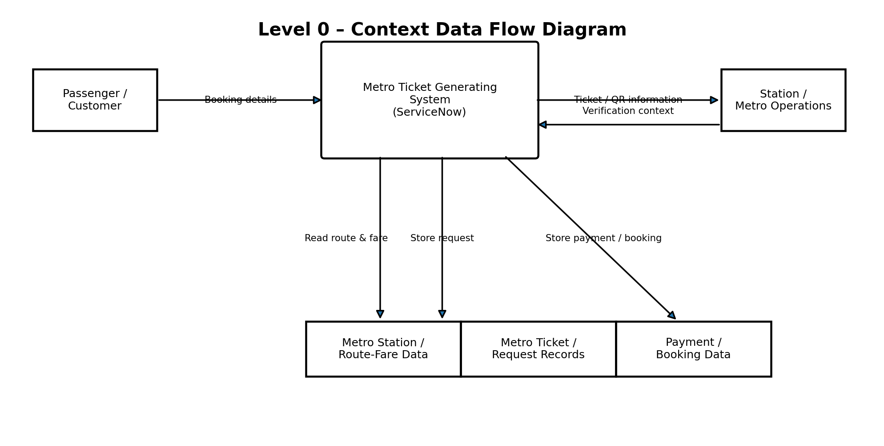
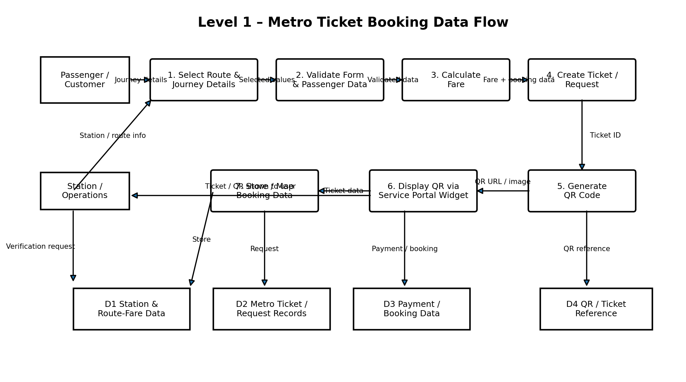

User Stories
User stories are organized around the actual passenger booking flow and the administrator configuration/testing work documented for the ServiceNow project.
User Type | Functional Requirement (Epic) | User Story Number | User Story / Task | Acceptance Criteria | Priority | Release
Passenger / Customer | Ticket Booking | USN-1 | As a passenger, I can open the Book a Metro Ticket catalog item and enter my journey details. | The booking form is accessible and displays the required journey fields. | High | Sprint-1
Passenger / Customer | Station Selection | USN-2 | As a passenger, I can select the Starting From station. | A valid station can be selected from the reference list. | High | Sprint-1
Passenger / Customer | Station Selection | USN-3 | As a passenger, I can select the Going To station. | A valid destination station can be selected from the reference list. | High | Sprint-1
Passenger / Customer | Journey Type | USN-4 | As a passenger, I can choose Single Journey or Return Journey. | The selected journey type is retained and the applicable amount field is used. | High | Sprint-1
Passenger / Customer | Passenger Details | USN-5 | As a passenger, I can select the number of passengers. | The passenger count is accepted from the configured choices and is used in fare calculation. | High | Sprint-1
Passenger / Customer | Fare Calculation | USN-6 | As a passenger, I can see the fare calculated from my selected route, journey type and passenger count. | The appropriate fare is automatically populated; unrelated fare fields are cleared when applicable. | High | Sprint-2
Passenger / Customer | Payment | USN-7 | As a passenger, I can select a payment mode. | Configured payment choices such as UPI, Card or Others are available. | Medium | Sprint-2
Passenger / Customer | Payment | USN-8 | As a passenger, I can enter a payment mode detail when I select Others. | The Enter Payment Mode field becomes visible when Mode of Payment is Others. | Medium | Sprint-2
Passenger / Customer | Validation | USN-9 | As a passenger, I can submit the request only after the required booking information is completed. | Mandatory and non-empty field validations prevent incomplete submissions. | High | Sprint-2
Passenger / Customer | QR Ticket | USN-10 | As a passenger, I can receive a QR code after submitting my metro ticket request. | The submission flow generates a QR-code URL and presents the QR ticket to the user. | High | Sprint-3
Passenger / Customer | Portal Experience | USN-11 | As a passenger, I can view my QR ticket through the Service Portal. | The Metro QR Widget displays the QR image and ticket message. | High | Sprint-3
Station / Metro Operations | Ticket Verification | USN-12 | As a station/metro operations user, I can use the passenger's QR ticket as digital proof of the booking. | The passenger can present the generated QR ticket at the station for the intended verification process. | Medium | Sprint-3
Administrator | Catalog Administration | USN-13 | As an administrator, I can configure the Book a Metro Ticket catalog item and its variables. | The catalog item contains the configured station, journey, passenger, fare and payment variables. | High | Sprint-1
Administrator | Automation | USN-14 | As an administrator, I can configure Catalog Client Scripts and UI Policies for booking automation. | Fare automation, conditional field visibility and submission QR generation operate according to the configured logic. | High | Sprint-2
Administrator | Security | USN-15 | As an administrator, I can protect backend ticket data using role-based access controls. | Customers can use the booking experience without direct access to restricted backend database records. | High | Sprint-3
Administrator | Testing & Quality | USN-16 | As an administrator, I can test booking form behaviour, fare calculation, QR generation and visibility. | Configured test cases produce the expected form, fare and QR outcomes. | High | Sprint-4

